**CSCI241 – Homework #4 (Logic Gates)  
Name: ________________**

**74LS00 – Quad 2-input NAND Gate**

**74LS02 – Quad 2-input NOR Gate**

**74LS04 – Hex Inverters**

**74LS08 – Quad 2-input AND Gate**

**Pin Layout:**

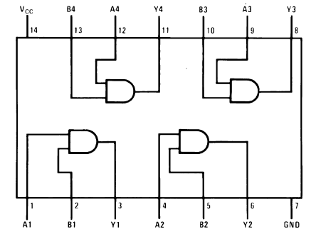

**Truth Tables:**

**Gate #1**

|  |  |  |
| --- | --- | --- |
| **Input A (Pin 1)** | **Input B (Pin 2)** | **Output Y (Pin 3)** |
| **LOW** | **LOW** | **LOW, 0.00 v** |
| **LOW** | **HIGH** | **LOW, 0.00 v** |
| **HIGH** | **LOW** | **LOW, 0.00 v** |
| **HIGH** | **HIGH** | **HIGH, 4.98 v** |

**Gate #2**

|  |  |  |
| --- | --- | --- |
| **Input A (Pin 4)** | **Input B (Pin 5)** | **Output Y (Pin 6)** |
| **LOW** | **LOW** | **LOW, 0.00 v** |
| **LOW** | **HIGH** | **LOW, 0.00 v** |
| **HIGH** | **LOW** | **LOW, 0.00 v** |
| **HIGH** | **HIGH** | **HIGH, 4.98 v** |

**Gate #3**

|  |  |  |
| --- | --- | --- |
| **Input A (Pin 9)** | **Input B (Pin 10)** | **Output Y (Pin 8)** |
| **LOW** | **LOW** | **LOW, 0.00 v** |
| **LOW** | **HIGH** | **LOW, 0.00 v** |
| **HIGH** | **LOW** | **LOW, 0.00 v** |
| **HIGH** | **HIGH** | **HIGH, 4.98 v** |

**Gate #4**

|  |  |  |
| --- | --- | --- |
| **Input A (Pin 12)** | **Input B (Pin 13)** | **Output Y (Pin 11)** |
| **LOW** | **LOW** | **LOW, 0.00 v** |
| **LOW** | **HIGH** | **LOW, 0.00 v** |
| **HIGH** | **LOW** | **LOW, 0.00 v** |
| **HIGH** | **HIGH** | **HIGH, 4.98 v** |

**74LS11 – Triple 3-input AND Gate**

**74LS32 – Quad 2-input OR Gate**

**74LS86 – Quad 2-input XOR Gate**

**74LS03 – Quad 2-input NAND Gate with Open Collector Outputs**